**[TITLE OF COURSE]**

Course Design – Template for content creators & SMEs

Curriculum Structure in LearnPress 2

My Course Curriculum Structure 4

Learning Objectives Overview for Course 5

How to create a micro-teach 6

Course Overview 6

Section 1: [SECTION TITLE] 7

[What?] 7

Lesson 1.1: [LESSON TITLE] 7

Lesson 1.2: [LESSON TITLE] 7

Lesson 1.3: [LESSON TITLE] 8

Section 2: [SECTION TITLE] 10

[Why?] 10

Lesson 2.1: [LESSON TITLE] 10

Lesson 2.2: [LESSON TITLE] 11

Lesson 2.3: [LESSON TITLE] 11

Lesson 2.4: [LESSON TITLE] 11

Section 3: [SECTION TITLE] 12

[How] 12

Lesson 3.1: [LESSON TITLE] 12

Lesson 3.2: [LESSON TITLE] 12

# Curriculum Structure in LearnPress

**Course**

Reading Graphs

**Section 1**

Cause and Effect, Independent and Dependent Variables

**Lessons**

What is it?

Why is it important?

How do we do it?

Let’s practise

**Section 2**

Logarithmic Axes

**Lessons**

What is it?

Why is it important?

How do we do it?

Let’s practise

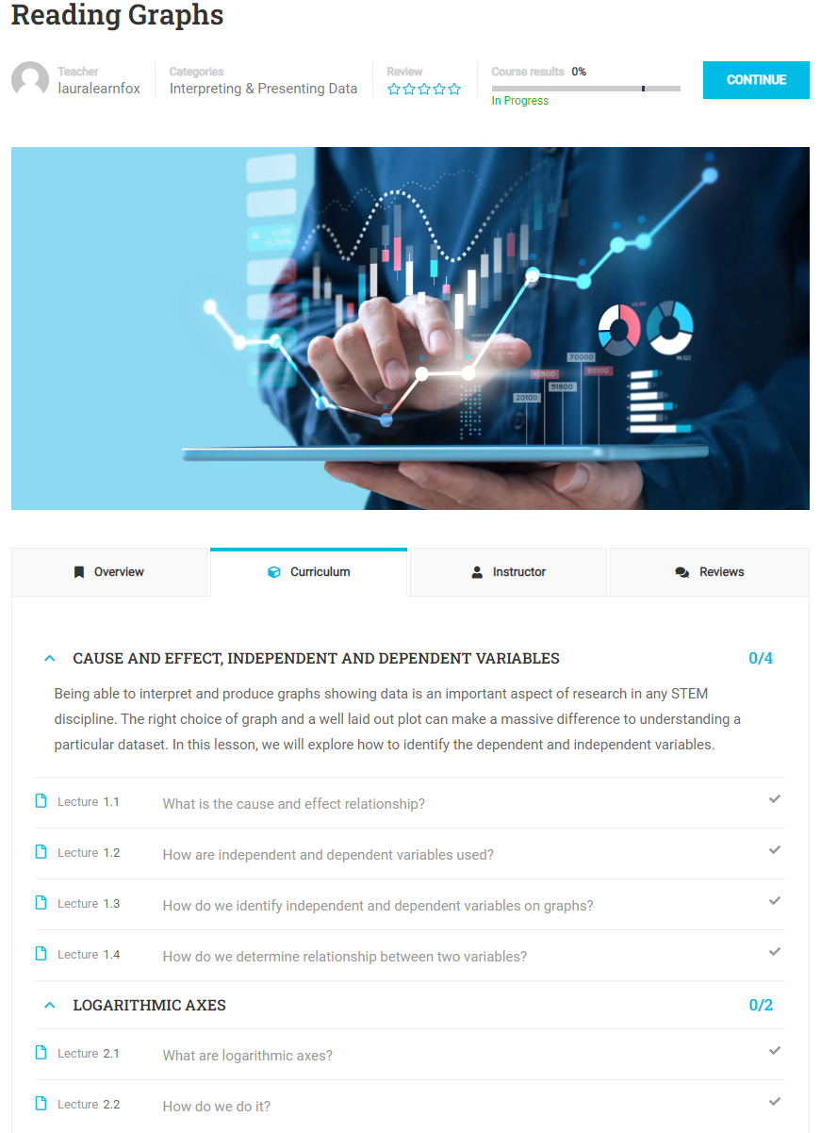

Each Course is a discrete sub-topic within Research Methods and will have it’s own Learning Objectives. The Lessons within the Course will be the micro-learning Lessons within the Course. So for example, ‘Reading Graphs’ is a Course (discrete sub-topic) within Research Methods, and will further break down into Sections such as ‘Units and Types of Data’, ‘Logorithmic Axes’, ‘Graphs’, Presenting Freqeuency Information’ and so on.

The first thing to do is to identify your disceret sub-topic within the field of Research Methods and break it down into the micro-learning Sections to form your curriculum.

The next thing to do is to then idenrify the Lessons which will make up each of the sections within your course. The Lessons within each Section could be:

* What is it?
* Why is it important?
* How do we do/ or apply it?
* Let’s practise

These Lessons can be given a more meaningful title related to the content of your Course but the learning objectives and content should cover off the ‘what’, the ‘why’ and the ‘how’ and end with an opportunity to invite the learner to apply what they’ve learned with a practise activity.

# My Course Curriculum Structure

You will create your curriculum within your Course in LearnPress. This is what the Curriculum looks like for my ‘How to Create a Microteach’ course:

**Course**

[COURSE TITLE

**Section 1**

[SECTION 1]

**Lessons**

* 1.1: [LESSON TITLE]
* 1.2: [LESSON TITLE]
* 1.3: [LESSON TITLE]
* 1.4: [LESSON TITLE]

**Section 2**

[SECTION 2]

**Lessons**

* 2.1: [LESSON TITLE]
* 2.2: [LESSON TITLE]
* 2.3: [LESSON TITLE]
* 2.4: [LESSON TITLE]

**Section 3**

[SECTION 3]

**Lessons**

* 3.1: [LESSON TITLE]
* 3.2: [LESSON TITLE]

# Learning Objectives Overview for Course

After this course you will be able to…

1. [LEARNING OUTCOME 1]
2. [LEARNING OUTCOME 2]
3. [LEARNING OUTCOME 3]
4. [LEARNING OUTCOME 4]
5. [LEARNING OUTCOME 5]

All learning objectives are covered at least once in the items of this course. Please find the track record here:

|  |  |  |
| --- | --- | --- |
| **Objective** | **Item** | **Assessed by activity or knowldge check?** |
| [LEARNING OUTCOME 1] |  | Y/N |
| [LEARNING OUTCOME 2] |  | Y/N |
| [LEARNING OUTCOME 3] |  | Y/N |
| [LEARNING OUTCOME 4] |  | Y/N |
| [LEARNING OUTCOME 5] |  | Y/N |

# How to create a micro-teach

## Course Overview

|  |
| --- |
| **Goals/ Learning Objectives:**   * Setting the stage / share expectations of this course, present learning objectives.   **Methods used (high level):**  **Format used (more specific):** |

**Text/ Copy:**

|  |
| --- |
|  |

**What you will learn**

|  |
| --- |
| After this course you will be able to…   1. [LEARNING OUTCOME 1] 2. [LEARNING OUTCOME 2] 3. [LEARNING OUTCOME 3] 4. [LEARNING OUTCOME 4] 5. [LEARNING OUTCOME 5] |

# Section 1: [SECTION TITLE]

# [What?]

## Lesson 1.1: [LESSON TITLE]

|  |
| --- |
| **Goals/ Learning Objectives:**   1. [LEARNING OUTCOME] 2. [LEARNING OUTCOME]   **Methods used:**  **Format used:** |

**[TYPE OF ITEM e.g. TEXT, GRAPHIC, VIDEO, TYPE OF H5P INTERACTION]**

Input text/ copy, graphics, links, videos or detail of H5P interaction…

**[TYPE OF ITEM e.g. TEXT, GRAPHIC, VIDEO, TYPE OF H5P INTERACTION]**

|  |
| --- |
|  |

## Lesson 1.2: [LESSON TITLE]

|  |
| --- |
| **Goals/ Learning Objectives:**   1. [LEARNING OUTCOME] 2. [LEARNING OUTCOME]   **Methods used:**  **Format used:** |

**[TYPE OF ITEM e.g. TEXT, GRAPHIC, VIDEO, TYPE OF H5P INTERACTION]**

## Lesson 1.3: [LESSON TITLE]

|  |
| --- |
| **Goals/ Learning Objectives:**   1. [LEARNING OUTCOME] 2. [LEARNING OUTCOME]   **Methods used:**  **Format used:** |

**[TYPE OF ITEM e.g. TEXT, GRAPHIC, VIDEO, TYPE OF H5P INTERACTION]**

Lesson 1.4: [LESSON TITLE]

**[TYPE OF ITEM e.g. TEXT, GRAPHIC, VIDEO, TYPE OF H5P INTERACTION]**

|  |
| --- |
|  |

**[TYPE OF ITEM e.g. TEXT, GRAPHIC, VIDEO, TYPE OF H5P INTERACTION]**

|  |
| --- |
|  |

# Section 2: [SECTION TITLE]

# [Why?]

## Lesson 2.1: [LESSON TITLE]

|  |
| --- |
| **Goals/ Learning Objectives:**   1. [LEARNING OUTCOME] 2. [LEARNING OUTCOME]   **Methods used:**  **Format used:** |

**[TYPE OF ITEM e.g. TEXT, GRAPHIC, VIDEO, TYPE OF H5P INTERACTION]**

|  |
| --- |
|  |

## Lesson 2.2: [LESSON TITLE]

**[TYPE OF ITEM e.g. TEXT, GRAPHIC, VIDEO, TYPE OF H5P INTERACTION]**

|  |
| --- |
|  |

## Lesson 2.3: [LESSON TITLE]

**[TYPE OF ITEM e.g. TEXT, GRAPHIC, VIDEO, TYPE OF H5P INTERACTION]**

|  |
| --- |
|  |

## Lesson 2.4: [LESSON TITLE]

**[TYPE OF ITEM e.g. TEXT, GRAPHIC, VIDEO, TYPE OF H5P INTERACTION]**

|  |
| --- |
|  |

# Section 3: [SECTION TITLE]

# [How]

## Lesson 3.1: [LESSON TITLE]

|  |
| --- |
| **Goals/ Learning Objectives:**   1. [LEARNING OUTCOME] 2. [LEARNING OUTCOME]   **Methods used:**  **Format used:** |

**[TYPE OF ITEM e.g. TEXT, GRAPHIC, VIDEO, TYPE OF H5P INTERACTION]**

|  |
| --- |
|  |

## Lesson 3.2: [LESSON TITLE]

**[TYPE OF ITEM e.g. TEXT, GRAPHIC, VIDEO, TYPE OF H5P INTERACTION]**

|  |
| --- |
|  |