**How to create a microteach**

Course Design – Template for content creators & SMEs

Curriculum Structure in LearnPress 2

My Course Curriculum Structure 4

Learning Objectives Overview for Course 5

How to create a micro-teach 7

Course Overview 7

Section 1: What is a microteach? 8

[What?] 8

Lesson 1.1: What is microlearning? 8

Lesson 1.2: What’s the purpose of this website? 10

Lesson 1.3: Good practice guidance 10

Section 2: What’s the process for creating my microteach? 14

[Why?] 14

Lesson 2.1: Overview of the workflow process 14

Lesson 2.2: The Design phase 16

Lesson 2.3: The Build phase 16

Lesson 2.4: Review & Publish 17

Section 3: How do I get started? 18

[How] 18

Lesson 3.1: Recap and quick-steps to get started! 18

Lesson 3.2: Test Your knowledge! 19

# Curriculum Structure in LearnPress

**Course**

Reading Graphs

**Section**

Cause and Effect, Independent and Dependent Variables

**Lessons**

What is it?

Why is it important?

How do we do it?

Let’s practise

**Section**

Logarithmic Axes

**Lessons**

What is it?

Why is it important?

How do we do it?

Let’s practise

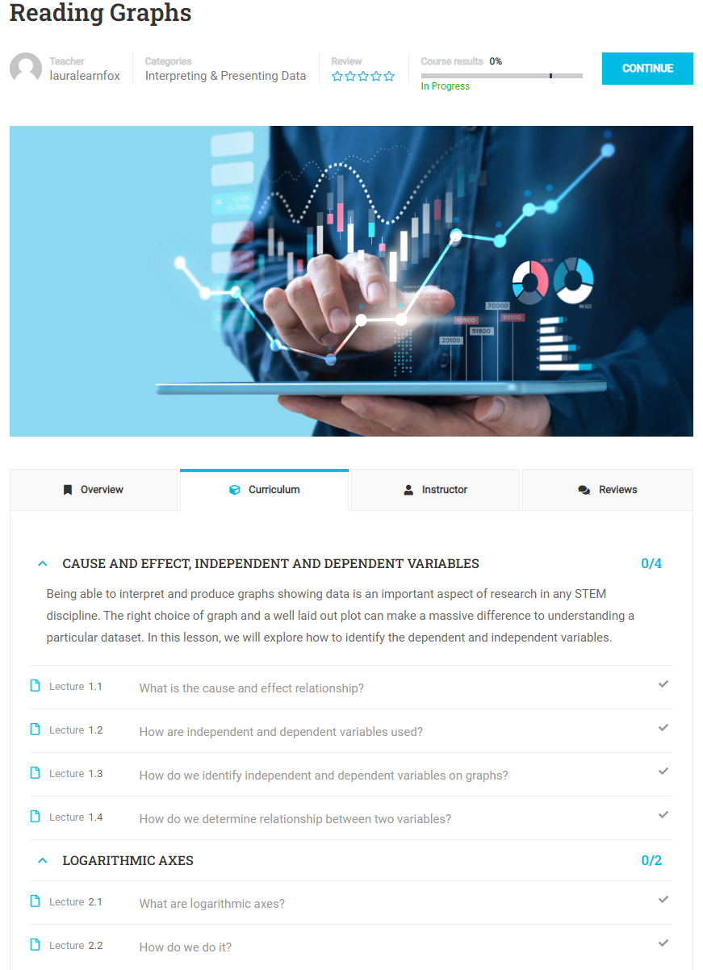

Each Course is a discrete sub-topic within Research Methods and will have it’s own Learning Objectives. The Lessons within the Course will be the micro-learning Lessons within the Course. So for example, ‘Reading Graphs’ is a Course (discrete sub-topic) within Research Methods, and will further break down into Sections such as ‘Units and Types of Data’, ‘Logorithmic Axes’, ‘Graphs’, Presenting Freqeuency Information’ and so on.

The first thing to do is to identify your disceret sub-topic within the field of Research Methods and break it down into the micro-learning Sections to form your curriculum.

The next thing to do is to then idenrify the Lessons which will make up each of the sections within your course. The Lessons within each Section could be:

* What is it?
* Why is it important?
* How do we do/ or apply it?
* Let’s practise

These Lessons can be given a more meaningful title related to the content of your Course but the learning objectives and content should cover off the ‘what’, the ‘why’ and the ‘how’ and end with an opportunity to invite the learner to apply what they’ve learned with a practise activity.

# My Course Curriculum Structure

You will create your curriculum within your Course in LearnPress. This is what the Curriculum looks like for my ‘How to Create a Microteach’ course:

**Course**

How to create a micro-teach

**Section 1**

What is a micro-teach?

**Lessons**

* 1.1: What is microlearning?
* 1.2: What’s the purpose of this website
* 1.3: Good practice guidance
* 1.4: Learning Objectives

**Section 2**

What’s the process for creating my micro-teach?

**Lessons**

* 2.1: Overview of process: Design – Build – Review - Publish
* 2.2: Design phase – (include Learning Design template, how to create Learning Objectives)
* 2.3: Build phase – ‘how to video’ on creating Course and Lessons in LearnPress (include finding H5P interactions)
* 2.4: Review & Publish phase – quick overview of who to contact

**Section 3**

How do I get started?

**Lessons**

* 3.1: Recap on process: Design- Build – Review – Publish
* 3.2: Test your knowledge – assessment quiz

# Learning Objectives Overview for Course

After this course you will be able to…

1. Explain the key benefits of microlearning
2. Recall 3-5 best practice tips on creating microlearning assets
3. Summarize the workflow process for creating a microteach to be included on the website
4. Find and download the Learning Design template to start planning your microteach
5. Organize your content into an appropriate structure for the website of ‘Course- Lessons- Sections’
6. Define meaningful learning objectives for your microteach
7. Apply the microlearning best practice tips and develop your own Learning Design using the template
8. Select appropriate and varied H5P interactions to make your content engaging
9. Build your microteach within LearnPress
10. Get started with confidence with building your microteach

All learning objectives are covered at least once in the items of this course. Please find the track record here:

|  |  |  |
| --- | --- | --- |
| **Objective** | **Item** | **Assessed by activity or knowldge check?** |
| Explain the key benefits of microlearning | Lesson 1.1 - Section 1 | Y  Test Your Knowledge in  Lesson 1.3  Section 2 |
| Recall 3-5 best practice tips on creating microlearning assets | Lesson 1.1 - Section 3 | Y  Test Your Knowledge in  Lesson 1.3  Section 2 |
| Summarize the workflow process for creating a microteach to be included on the website | Lesson 1.2 - Section 1 | Y  Test Your Knowledge in  Lesson 1.3  Section 2 |
| Find and download the Learning Design template to start planning your microteach | Lesson 1.2 -Section 2  &  Lesson 1.3 -Section 1 | N |
| Organize your content into an appropriate structure for the website of ‘Course- Lessons- Sections’ | Lesson 1.2 - Section 2 | N |
| Define meaningful learning objectives for your microteach | Lesson 1.1 - Section 3 | Partly  Test Your Knowledge in  Lesson 1.3  Section 2 |
| Apply the microlearning best practice tips and develop your own Learning Design using the template | Lesson 1.1 - Section 3 | N |
| Select appropriate and varied H5P interactions to make your content engaging | Lesson 1.2 - Section 3 | Partly  Test Your Knowledge in  Lesson 1.3  Section 2 |
| Build your microteach within LearnPress | Lesson 1.2 - Section 3 | N  Can only be assessed when it’s submitted for Review |
| Get started with confidence with building your microteach | Lesson 1.3 - Section 1 | Y  Test Your Knowledge in  Lesson 1.3  Section 2 |

# How to create a micro-teach

## Course Overview

|  |
| --- |
| **Goals/ Learning Objectives:**   * Setting the stage / share expectations of this course, present learning objectives.   **Methods used (high level):**   * Reading   **Format used (more specific):**   * Text * Graphic could be used if appropriate one sourced |

**Text/ Copy:**

|  |
| --- |
| Welcome to this course on how to create a microteach. The purpose of this course is to onboard Subject Matter Experts (SMEs) in Research Methods (such as lecturers and academics) who want to deliver engaging microlearning via this website to students.  The course will provide some best practice guidance on designing and building a microteach, the workflow process for publishing your content on this website, and guidance on how to build your content in LearnPress. |

**What you will learn**

|  |
| --- |
| By the end of this microteach you will be able to:   1. Explain the key benefits of microlearning 2. Understand the purpose of this website 3. Recall 3-5 best practice tips on creating microlearning assets 4. Summarize the workflow process for creating a microteach to be included on the website 5. Find and download the Learning Design template to start planning your microteach 6. Organize your content into an appropriate structure for the website of ‘Course- Lessons- Sections’ 7. Define meaningful learning objectives for your microteach 8. Apply the microlearning best practice tips and develop your own Learning Design using the template 9. Select appropriate and varied H5P interactions to make your content engaging 10. Build your microteach within LearnPress |

# Section 1: What is a microteach?

# [What?]

## Lesson 1.1: What is microlearning?

|  |
| --- |
| **Goals/ Learning Objectives:**   1. Explain the key benefits of microlearning   **Methods used:**   * Reading * Infographic for context setting * Watching video   **Format used:**   * Text & graphic * Video |

**Text with image:**

Microlearning is an educational strategy that breaks complex topics down into short-form, stand-alone units of study that can be viewed as many times as necessary, whenever and wherever the learner has the need. Microlearning instructional modules are designed to be consumed in about five minutes and address one specific skill or knowledge gap topic.

The modern learner is easily distracted, highly visual, on the move, impatient and wants access to information on-demand.

We all may well find ourselves:

- surfing the internet three times (or more) per hour in the working day.

- looking at our smartphone dozens of times per hour

- prone to solving on-the-spot problems by accessing our smartphone for solutions

- learning more from search engines than books or manuals

- often asking a colleague how to solve a problem or sharing new findings with a peer

- considering taking a course on LinkedIn Learning, Udemy or Coursera to learn something new

- often feeling impatient, distracted and overwhelmed.

Microlearning is a strategy to engage the modern learner with bite-sized learning units with just enough information to achieve a goal, typically 3-5 mins. Unlike more traditional forms of learning, microlearning fits more naturally into the daily workflow and should include a mix of activities in addition to text and images including video, animation, quizzes, games, activities, reflection opportunities and possibly even user-generated content (through social sharing, videos, comments or forums).

ALT Text:

Meet the Modern Learner – Bersin by deloitte

# 

|  |
| --- |
| ALT Text:  Text/ Copy:  This video provides suggestions for free microlearning apps and websites that use a short-form approach to learn something new*.*  <https://youtu.be/nX7Mt6rccls> |

## Lesson 1.2: What’s the purpose of this website?

|  |
| --- |
| **Goals/ Learning Objectives:**   1. Understand the purpose of this website   **Methods used:**   1. Reading   **Format used:**   1. Text |

**Text with image:**

This website has been developed as part of a UK-China-BRI Education Partnership Initiative “A Mobile and Open learning and networking platform for Science and Engineering” funded by the British Council. The project is a collaboration between the University of Portsmouth, UK, Shanghai Jiao Tong University, China, and Hanoi University of Science and Technology, Vietnam.

The purpose of this website is to provide an alternative microlearning and mobile-accessible syllabus to enhance and enrich the learning experience for students learning essential research skills in Science and Engineering.

The research team will be focussing on how learner-focused micro-learning improves student engagement and learning outcomes in higher education. The research will explore academic, cognitive, emotional, and psychological engagement.

## Lesson 1.3: Good practice guidance

|  |
| --- |
| **Goals/ Learning Objectives:**   1. Recall 3-5 best practice tips on creating microlearning assets 2. Define meaningful learning objectives for your microteach   **Methods used:**   * Reading * Bloom’s Taxonomy * Learning Objectives – measurable verbs * Knowledge check question   **Format used:**   * Text & graphics  1. Multiple Choice Questions (MCQ) |

**Text with image:**

To optimize engagement here are some general design guidelines to bear in mind when creating microlearning:

1. Maximise user engagement by using accessible language, ensuring learning pathways are clear and that participants can see their progress clearly.
2. Make the content bitesize and easily consumable and clearly identify durations of learning assets. Ensure that bitesize assets are searchable and easily surfaced.
3. Increase interactivity by including practice activities, tasks and self-assessments to apply learning to their personal experience.
4. Optimize the peer learning experience using calls to action to get participants to share experiences with peers via the discussion
5. Keep videos short and no more than 5 mins. Videos that exceed 2 mins get less engagement so when a longer video might be necessary consider whether it could be broken down into smaller videos and perhaps even broken up with knowledge check questions or student interactivity.
6. Use a consistent format and structure for your microteach content so that students know what to expect.
7. Within LearnPress there are a variety of H5P interactions to make the learning experience more engaging. Choose a variety of interactions to keep sudents engaged whilst ensuring that interactions are appropriate to your learning objectives and whether you are presenting information or engaging students in an activity to embed the learning.

Always build with mobile in mind to increase accessibility. Luckily we have created this website with mobile in mind and so microlearning will be accessible to learners via their mobiles. But do test your microteach on your mobile device to ensure that image sizes and interactions appear correctly on mobile and provide a good user experience.

Lesson 1.4: Learning Objectives

**Text & graphic:**

|  |
| --- |
| Learning Objectives  The purpose of learning objectives is to set learners’ expectations about what they should be able to do after doing the content and enable you to ensure that they are being covered within the microteach content.  Where possible they should be:   * Measurable (use verbs that are observable actions, more specific than just to ‘know’) * Specific, clear and concise * **SMART** – Specific, Measurable, Attainable, Results focused, Time focused) * Using Bloom’s taxonomy – quick refresher   https://tips.uark.edu/wp-content/uploads/2013/09/Blooms_Taxonomy_pyramid_cake-style-use-with-permission.jpg  ALT Text: |

**Text & Graphic:**

|  |
| --- |
| ALT Text:  Measurable verbs to use when crafting learning objectives:  Source: <https://connected.unmc.edu/blog/2018/08/28/choosing-right-verb-learning-objective/> |

# Section 2: What’s the process for creating my microteach?

# [Why?]

## Lesson 2.1: Overview of the workflow process

|  |
| --- |
| **Goals/ Learning Objectives:**   1. Summarize the workflow process for creating a microteach to be included on the website 2. Find and download the Learning Design template to start planning your microteach 3. Organize your content into an appropriate structure for the website of ‘Course- Lessons- Sections’ 4. Apply the microlearning best practice tips and develop your own Learning Design using the template 5. Select appropriate and varied H5P interactions to make your content engaging 6. Build your microteach within LearnPress   **Methods used:**   * Reading * Watching video – walkthrough of using LD template * Downloadable template – Learning Design TEMPLATE * Worked example – Sam’s example   **Format used:**   * Text * Graphic * Video * Downloadable template |

**Text & Graphic**

|  |
| --- |
| Text/ Copy:  Creating effective digital learning requires more than just uploading content online. When students are learning asynchronously the content needs to be relevant, engaging and a variety or appropriate modalities need to be used to engage learners. Learners also need to be able to connect with the content applying meaning to it, making connections and applying it to their own experiences to make it more ‘sticky’.  What this means for educators and subject matter experts (SMEs) is that a considered process and approach is required to ensure that:   * content fulfills the necessary learning objectives * content is engaging and relevant * the digital modalities and interactions available are optimized   Governance and consistency is also key for this website to be an effective resource and to fulfill it’s purpose to enhance and enrich the learning experience for students learning essential research skills in Science and Engineering.  To facilitate this governance and optimize the efficacy we have devised this workflow process:    As a general guideline, I would advise that 70% of the effort is in the design, 20% is in building, and 10% is in reviewing and refining. Once the content is designed and laid out in a Learning Design template then it should be fairly quick and easy to transpose your design onto the website ready for review and publishing.  The workflow process consists of the following four phases:   * DESIGN:   + This is where the heavy lifting of your microlearning is done. This is essentially a blueprint or storyboard that can then be transposed onto the website. * BUILD:   + If you’ve done the design carefully then your build should be fairly quick and easy. You will need to get access to the website through Raymond Lee, and to familiarize yourself with LearnPress using the guidance in this microteach. Then you should be able to easily build your course and lessons, copying and pasting your text and creating your H5P interactions as you go. * REVIEW:   + This is an optional consultation phase when you can request a 30 min video call with Raymond Lee and Laura Lee-Gibbs (if required) to review your design, content or build and get some actionable feedback. * PUBLISH:   + When you’re content is approved Raymond Lee will publish it on the website and it will be ‘live’ to share with students. |

## Lesson 2.2: The Design phase

**Text/ Graphic/ video / downloadable template**

|  |
| --- |
| Text/ Copy:  Remember that 70% of the effort is in the design and doing this carefully will ensure that it should be quick and easy to build.  Graphic: Add the process diagram with a circle zooming in on the DESIGN phase  Here’s more detail about what’s required in the Design phase:   * DESIGN:   + Your existing content might be in ppt, Word docs, lesson plans or even in a combination of these plus your own head!   + Start by identifying your microteach course ‘topic’ or ‘title’   + What are the learning objectives?   + How does your course ‘topic’ then break down into smaller lessons? Establish your course structure.   + Ensure that you’re covering the ‘what’, the ‘why’ and the ‘how’ of your topic. As an educator your learners won’t have access to you when accessing this content, so make sure you set the context explaining ‘what’ the concept is, and ‘why’ it matters before explaining ‘how’ to apply it.   + Download this Learning Design template to organize your content.   Downloadable Learning Design TEMPLATE [ add sanitized version of this when complete]   * + Choose your H5P interactions. H5P is built into the LearnPress builder so no external subscription is required. But for ease when you designing you might find it useful to see examples of the variety of H5P interactions available here: <https://h5p.org/content-types-and-applications>   **Video walk-through of Learning Design TEMPLATE** |

## Lesson 2.3: The Build phase

**Text/ Graphic/ video**

|  |
| --- |
| Text/ Copy:  Now you’re ready to build your microteach! If you’ve done the design carefully then your build should be fairly quick and easy and represents about 20%of the effort.  Graphic: Add the process diagram with a circle zooming in on the BUILD phase  Let’s take a deeper dive into what you need to do.   * BUILD:   + Request access to the website through Raymond Lee   + Familiarize yourself with LearnPress by watching the video in this microteach.   What is LearnPress?  This website is developed in WordPress a well known open-source content management system (CMS). LearnPress is a plugin to WordPress providing Learning Management System (LMS) functionality allowing us to create courses, lessons and interactive engaging digital microlearning content. It will also allow us to report on student usage as one measure of engagement.  Video walk-through of how to create a course and lessons and add H5P interactions  Now you should be able to easily build your course and lessons, copying and pasting your text from your Learning Design Template and creating your H5P interactions as you go. |

## Lesson 2.4: Review & Publish

**Text/ Graphic**

|  |
| --- |
| Text/ Copy:  Congratulations, by this point you will have designed and built a microteach! You’re hard work is done! If you would like to, you can request an OPTIONAL review call with Raymond Lee and Laura Lee-Gibbs (if required) where you can review your design, content or build and get some actionable feedback. This might be quite useful for your first contribution whilst you are getting used to the process and to using LearnPress.  Once your content has been approved Raymond Lee will publish it and it will be available to share via the website.  Graphic: Add the process diagram with a circle zooming in on the REVIEW & PUBLISH phase |

# Section 3: How do I get started?

# [How]

## Lesson 3.1: Recap and quick-steps to get started!

|  |
| --- |
| **Goals/ Learning Objectives:**   1. Get started with confidence with building your microteach   **Methods used:**   * Recap * Reading * Quick step guide * Knowledge check   **Format used:**   * Text * Graphic * Downloadable Learning Design Template * MCQs/ ordering questions/ true-fasle question |

**Text & graphic**

|  |
| --- |
| Text/ Copy:  Well done for completing this micoteach on ‘How to create a microteach’! Hopefully you feel equipped and ready to get started.  You should now have an appreciation of what microlearning is and why it is so important in engaging the modern learner, you should understand the purpose of this website, and should be able to recall 3-5 best practice tips on creating an effective microteach.  As a quick recap:   * The following is the workflow process for creating content in the website which can be downloaded as a PDF to refer back to.     Here are 3 quick steps to get started with creating your microteach:   1. Identify the learning objectives for your ‘topic’ or Course 2. Break down your ‘topic’ or course into sub-topics to fulfill the learning objectives 3. Organize your subject material by completing the Learning Design template   Download your Learning Design Template here |

## Lesson 3.2: Test Your knowledge!

**MCQs/ Ordering questions/ true-false questions**

|  |
| --- |
| Text/ Copy:  TEST YOUR KNOWLEDGE!   1. Which part of the workflow process represents 70% of the effort involved?    1. The design phase (correct)    2. The build phase    3. The review phase    4. The publishing phase 2. Can you put these tasks from the design phase into the right order? (correct order shown)    1. Identify the topic    2. Define the learning objectives    3. Identify how your topic breaks down into smaller sub-topics (or lessons) to fulfill the learning objectives    4. Download and complete the Learning Design template 3. What are the benefits of designing your microteach before building? (select all that apply)    1. Ensuring the content fulfills the intended learning objectives    2. Optimizing the digital modalities and interactions    3. Ensuring the content is relevant and engaging    4. Applying governance and consistency to the content on the website 4. Which of the following are possible to create using H5P the website?    1. Multiple choice questions    2. Branching scenarios    3. Interactive videos    4. Accordion    5. Drag and Drop tasks with images    6. Image hotspots    7. True/ false question    8. All these and lots more! 5. One of the benefits of defining learning objectives is to set learner’s expectations about what they will learn. True or false? (TRUE) 6. Microlearning should always use videos. True or false? (False) 7. Which of these are valid best practice tips for creating an engaging microteach? (Select all that apply)    1. Use accessible language    2. Clearly identify the duration it will take a student to consume the content (correct)    3. Where possible include practice activities, tasks and self assessments to apply to their personal experience (correct)    4. When using video limit videos to no more than 5 mins and consider breaking down longer videos into separate shorter ones (correct)    5. Always use videos (incorrect)    6. Always have a quiz at the end (incorrect) |